Team ID: PNT2022TMID52071

Project: Real-time communication system powered by AI for specially Abled

stomer rney

Cnntent &

Rewew

& Feedback

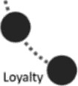

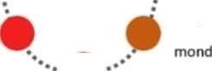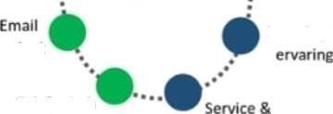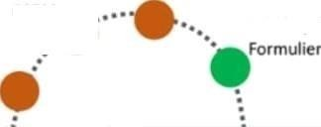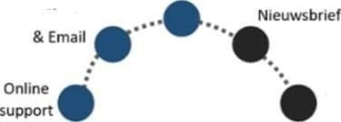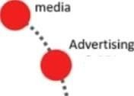

Landing

pages

Blog

Chat

Webshop &

Specific

Search

-'

Blog

engagement

Events & PR

Mond tot

contact

Levering &

Events

Te lefonisch

COOtflCt

piogramma